A CFL can be represented using either CFG or using a derivation tree.

Sentential form => Intermediate states during derivation of words using production rules

Left-most derivation => If at each step of the derivation process, we replace the left-most variable in the sentential form

Right-most derivation => If at each step of the derivation process, we replace the right-most variable in the sentential form

Non-linear grammars have multiple terminals at the end of the production rules.

Eg

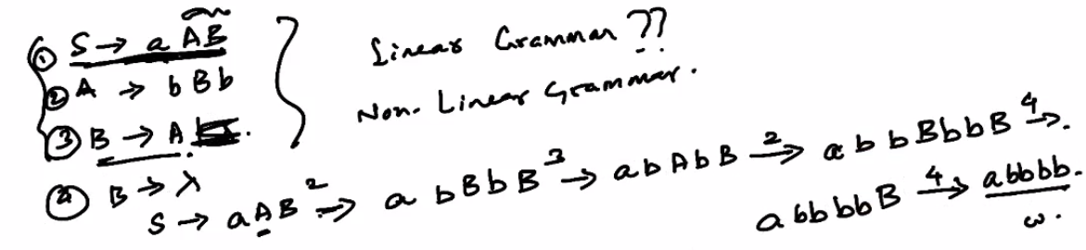

Hence abbbb is the left-most derivation of this grammar

Derivation tree

Let G = (V, T, S, P) be a CFG. An ordered tree is a derivation tree for the grammar G iff it has the following properties:

1. Root of the tree is labeled S
2. Every leaf node has a label from T U {Lambda}
3. Every interior node has a label V
4. If a node has label A belonging to V, and its children are labeled from left to right a1, a2 .. an, then there must exist a production of the form {A -> a1a2...an}
5. A leaf labeled Lambda has no siblings, and cannot have any other children

Derivation tree does not give order of the derivation

Eg

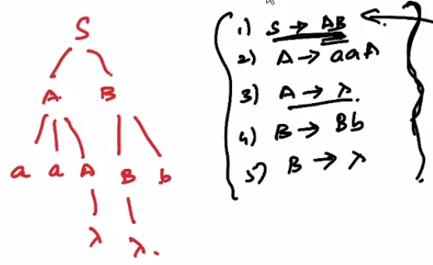

Parsing

Used to check whether given word belongs to language or not, from a derivation tree.

Exhaustive Search Parsing (Brute Force)

This is a form of top-down parsing. It constructs derivations from the root to the leaf nodes.

We simply exhaustively apply production rules and check if the sentential forms can derive the given word.

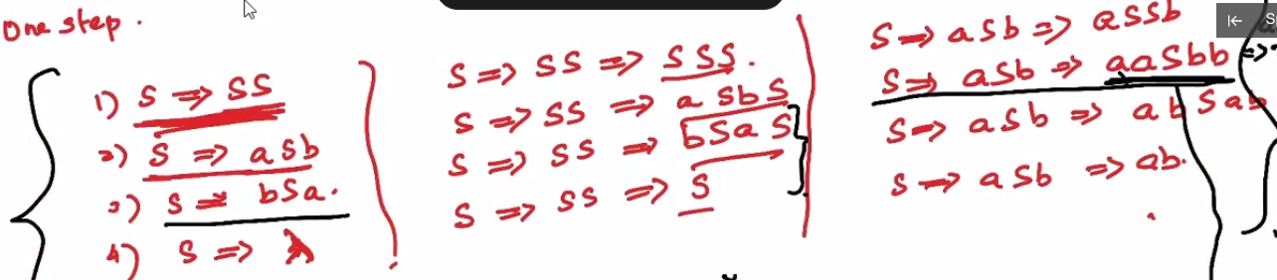

However there is a way to optimize this process

Suppose G = (V,T,S,P) is a CFG that does not have any rules of the form A -> Lambda or A -> B, where A, B belong to V, then the exhaustive search parsing can be made into an algorithm such that for every w belonging to Sigma\*, the algo generates a parsing for w or tells us that the parsing is not possible.

If length of sentential form exceeds length of string, there is no derivation possible which can give us the string w. This is because there are no productions of the form A -> Lambda or A -> B, hence length cannot be reduced.

1. Grammar (Simple Grammar)

A context free grammar G = (V, T, S, P) is said to be simple, if all its productions are of the form A -> ax where A belongs to V, a belongs to T and x belongs to V\*. Any pair (A, a) occurs only once in P.

S-grammars need not be linear.